**Test Case 5 – Basement walls that extend above grade and bound two different spaces**

*Test Description* : A two zone model that ensures exterior walls can properly be defined as underground and above grade. A single wall has been drawn by the user that begins below grade, and terminates above grade. Above grade, the walls bound a space that is above grade. Below grade, the walls bound a space that is entirely below grade.

*Space Names:* This is important because the gbXML validator requires the strings in the test file match the standard file. The name check is case sensitive. Ensure that the id attribute of the Space elements in the gbXML test file match the standard file space names shown below.

|  |  |  |
| --- | --- | --- |
| Standard File Space Name | Test File Space Name | Verified |
| sp-1-Space |  |  |
| sp-2-Space |  |  |

*Special Considerations:*

1. The windows in this model are openingType=”OperableWindow”
2. There are no interior walls in this test case.
3. The ground coupled slab in this test case is surfaceType=”UndergroundSlab”

*Complexity of the BIM Model:*

1. Simple planar surfaces orthogonal to the project Cartesian reference frame.
2. Simplified walls with no visible layers.
3. Simple details at interfaces of surfaces.
4. Egg shell models can be tested in this example.

*Description of Test:*

Figure 1 shows a simple 3D axonometric view of how the example is massed. In this case, the figure shows a basement (Space 1) separated from the space above grade (Space 2). The underground walls in space 1 are partially stubbed out above grade. Figure 1 is also referenced in the Example gbXML code section of this document to clearly identify how the exterior walls are created. Figure 2 shows how the walls in the basement start below grade and poke up above grade forming a small 2’ wall that forms the base of the enclosure for Space 2. It also shows the vertical position of the window, relative to the wall in which it is embedded (2’0-11/32”) and the height of the window (4’).

Figure 3 provides a plan view schematic of Space 2, the location of windows (centered), and the width of a window (2’). The wall thickness (8”) is not shown because it is identical to the wall thickness shown in Figure 4 that shows the dimensions of Space 1.

Roof

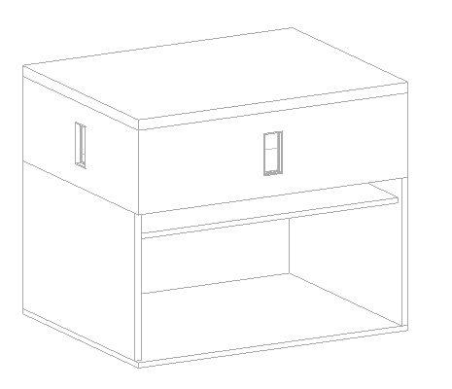

su-7

su-11

Basement

**N**

Floor Slab

Figure 1: Test case 5 shown in an axonometric cutaway view to reveal the qualitative relationship between the different surfaces and spaces. su-7 and su-11 reference the code snippets found at the end of this document.

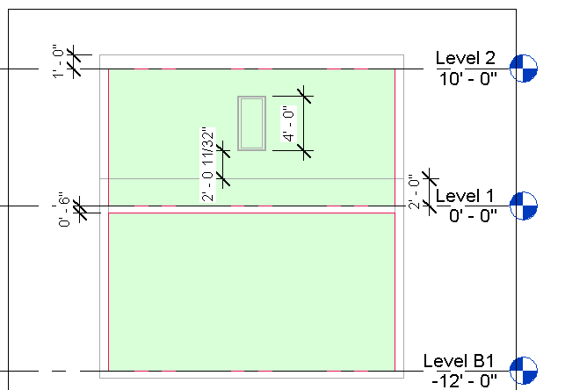

Space 2

Space 1

Figure 2: Section looking north that details the height of a space, the construction thicknesses of the floors, ceilings, and roof, The insertion height of the a typical window is also shown (2’-0 11/32”), as well as the height of a typical window (4’) are shown.

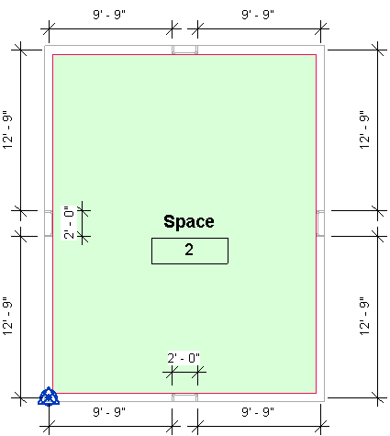

Figure 3: Space 1, located on the first floor. The dimensions of the windows, and their relative location in a given wall (centered) is also shown. Distances are taken from the centerlines of the wall. It is possible to do the arithmetic to find the total wall length, but this can also be found in Figure 4 below.

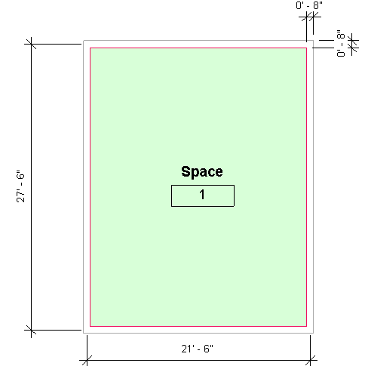

Figure 4: Plan view of Space 1 (basement) with the dimensions (centerline to centerline) and the wall thickness used throughout this project.

|  |  |  |  |
| --- | --- | --- | --- |
| Surface Description | Surface Thickness | Surface Type | Comments |
| Exterior Wall | 8” | n/a |  |
| Roof | 12” | n/a |  |
| Interior Floor Slab | 6” | n/a |  |

Table 1: Dimensions and descriptions of wall elements in Test Case 1.

*Example of the gbXML Code Relevant to this Example*

This test case will have no very unique cases that will require deep explanation, though some XML is presented below as an example.

Space 1 will see no unique gbXML, and so it is ignored. Simply understand that the Surface nodes have the attribute surfaceType=”UndergroundWall”

Space 2, however, will have a total of 8 walls, 4 of which will have Opening nodes as children, due to the windows. As per the implementation guide, the ShellGeometry node will still only contain 6 PolyLoop elements (one for each side of a cube), since the interior surface is not interrupted in any way. It is the SurfaceBoundary and Surface elements that will clarify the location and number of exterior walls for Space 2.

<Space id=”sp-Space-2” …>

…

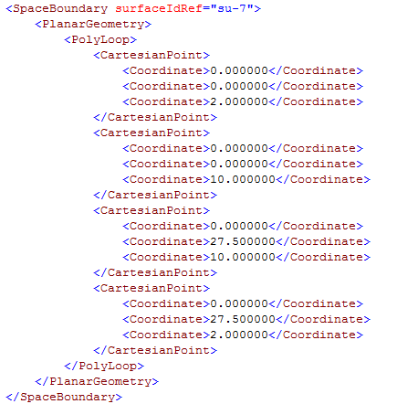

…

(continued on next page)

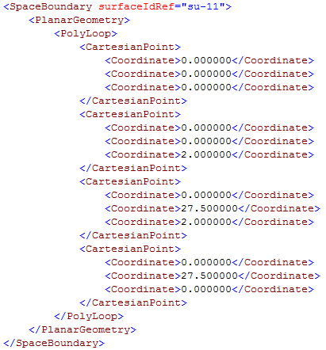

</Space>

Code Snippet 1: SpaceBoundary definitions for the west walls of Space 2 (also shown in Figure 1 for reference).

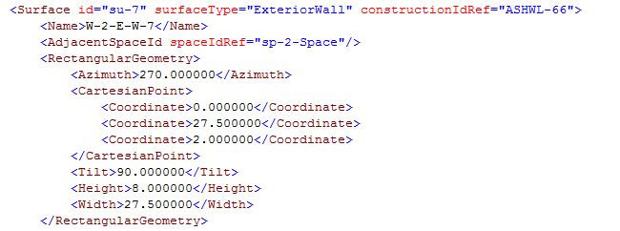

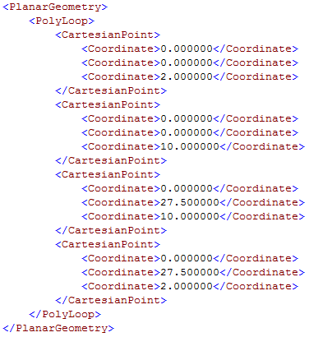

(continued on next page)

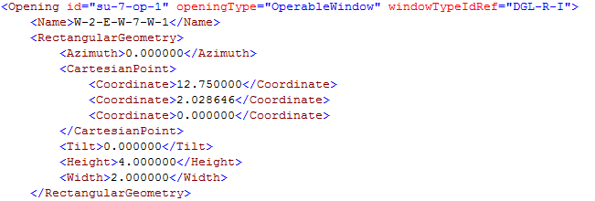

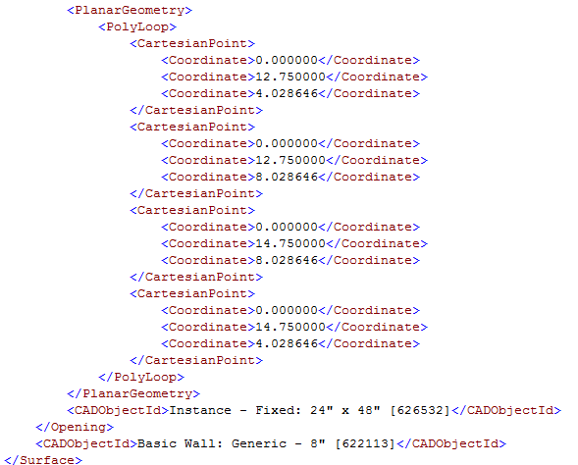

Code Snippet 2: An example of the Surface element in gbXML, for id=su-7. Note the gbXML for the opening (window) is also included.